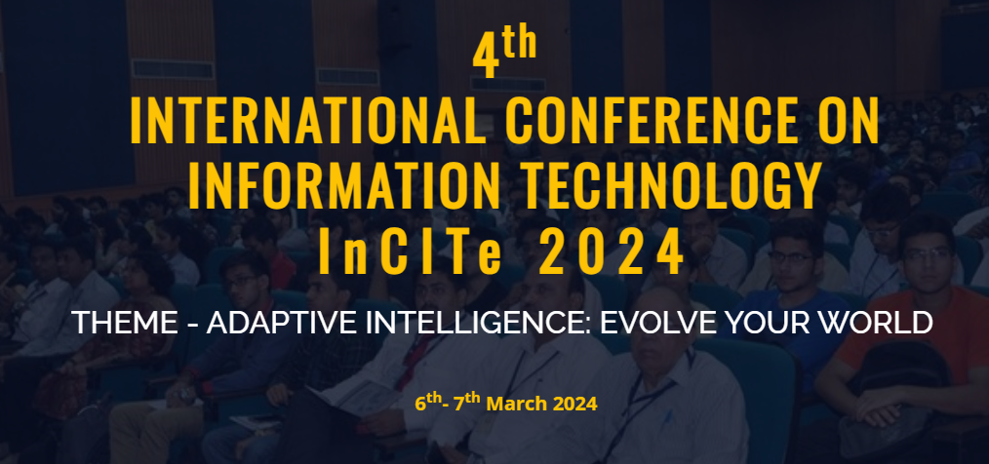

**REGISTRATION FORM**

I would like to participate in the conference:

|  |  |  |  |
| --- | --- | --- | --- |
| **Personal information**  **(Please type or print clearly in CAPITAL LETTERS)** | | | |
| **Title**: □Mr. □Mrs. □Ms. □Prof. □Dr. □Others (Please specify :___________________) | | | |
| **First Name** |  | **Position** |  |
| **Middle Name** |  | **Mobile No.** |  |
| **Last Name** |  | **Email ID** |  |
| **Department** |  | **Organization** |  |
| **Address of Organization** |  | | |
| **Paper Information (Only for Authors)** | | | |
| **Paper ID** |  | | |
| **Paper Title** |  | | |
|  | | |
| **Postal Address** | | | |
| **Address Line1** |  | | |
| **Address Line2** |  | | |
| **City** |  | | |
| **State** |  | | |
| **Postal Code** |  | | |
| **Country** |  | | |
| **Contact No.** |  | | |

|  |  |  |  |
| --- | --- | --- | --- |
|  |  |  | |
| |  |  |  |  |  | | --- | --- | --- | --- | --- | | **Category (Put √ on relevant Category)** | | | | | | **Author** | | | | **Delegate** | | Nationality | Students/Research Scholar (Full Time) | Academician | Corporate  Professionals |  | | Indian |  |  |  |  | | Foreign |  |  |  |  | | |  |
|  | |  |

|  |  |  |  |  |  |  |
| --- | --- | --- | --- | --- | --- | --- |
| **Details of Electronic Fund Transfer** | | | | | | |
| **Bank Name** | **Transaction Reference Number** | **Transaction ID** | **Date** | **Time** | **Amount** | **Amount (in words)** |
|  |  |  |  |  |  |  |

***Important Guidelines for Authors/Delegates***

**Technical Guidelines**

* The paper length should not exceed eight (8) pages.
* The authors can extend maximum two (2) pages, with over length page charge of Rs. 500/page for Indian participant and US $ 25/page for international participant. The maximum page submission limit is ten (10) pages.
* Copyright Form must be duly signed by the author(s) before sending the soft/hard copy of the form.
* Incorporate all the suggestions as suggested by the reviewers, in the Camera-Ready Paper.
* The entire publication process may take 4-6 months after the conference.

**Registration Guidelines**

* Each paper, in order to be published in the conference proceedings and final program, requires at least one author to be registered and to present the paper.
* If multiple authors of a paper wish to attend the conference, separate registration will be mandatory for each author.
* If an author has got more than one accepted papers, each paper has to be registered separately.
* It is mandatory to present the paper during conference for submission to Springer.
* Only registered authors can participate in conference and present their papers.
* In case the registered author is unable to present the paper, another co-author can present (With prior intimation). In such cases certificate and registration kit will be provided to the presenter only.
* For student/research scholars’ registration, only full-time research scholars and students will be considered. Students should send the scanned copy of the Identity Card along with the registration form.
* Select papers from the conference will be published by Springer as a proceedings book volume. Springer will conduct quality checks on the accepted papers and only papers that pass these checks will be published.

**Cancellation Guidelines**

* The Final decision regarding acceptance/rejection will be made by the Technical Program Committee.
* The Author(s) shall bear sole and exclusive responsibility for all violations of Springer norms.
* Springer reserves the rights for final inclusion of paper in proceedings book volume.
* If plagiarism found in paper at any level of publication process, then Committee has full rights to cancel the paper.

**Non Refund Guidelines**

* Once registration has been done, no amount will be refunded under any circumstances.
* No refund will be given if paper has been cancelled due to plagiarism at any level.
* No refund will be given if paper has been registered and not presented in the conference.
* No refund will be given if paper has been rejected by publisher at any stage.
* **I on behalf of all my co-authors confirm that no third-party material has been used in the manuscript.**
* **I on behalf of all my co-authors would submit duly signed permission for any third-party content if found to be used in the manuscript.**
* **I hereby confirm that I have read all the above-mentioned policies.**

**Date: Signature:**